- Select deDisplay the department number, number of employees, average salary, and maximum salary for employees whose names contain the letter A, considering only departments having at least 2 such employees.

SQL> select deptno,count(), avg(salary),max(salary) from employee where empname like '%A%' group by deptno having count() >=2;
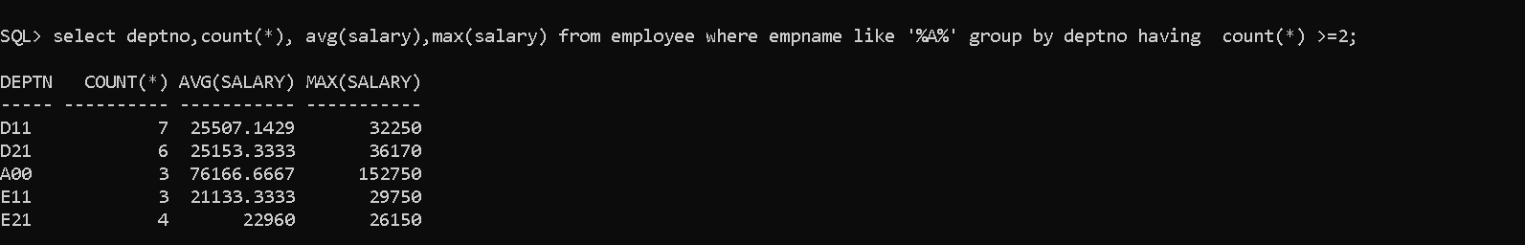
- Display the department number, number of employees, and average salary for employees whose job contains the word MANAGER, considering only departments where the average salary is greater than 40,000

SQL> select deptno,count(*), avg(salary) from employee where job like '%MANAGER%' group by deptno having avg(salary) >40000;

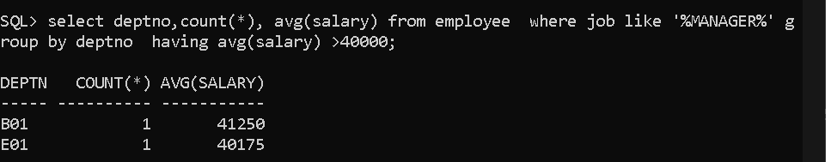

- Display the year of joining, number of employees, total salary, and average salary for each year in which employees joined, considering only years having more than 2 employees.

SQL> SELECT EXTRACT(YEAR FROM HIRE_DATE) AS YEAR,
2 COUNT(*) AS EMP_COUNT,
3 SUM(SALARY) AS TOTAL_SALARY,
4 AVG(SALARY) AS AVG_SALARY
5 FROM EMPLOYEE
6 GROUP BY EXTRACT(YEAR FROM HIRE_DATE)
7 HAVING COUNT(*) > 2;
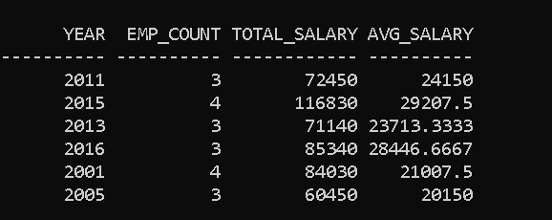

- Display the department number, number of employees, and average salary for employees who joined during the month of June, considering only departments having at least 2 such employees.

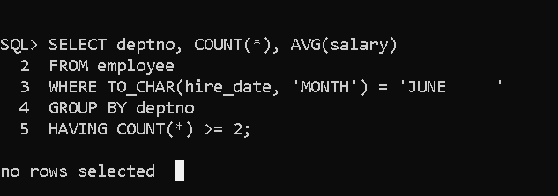

- Display the job, number of employees, and average salary for employees whose names start with the letter S, considering only jobs having more than one such employee.

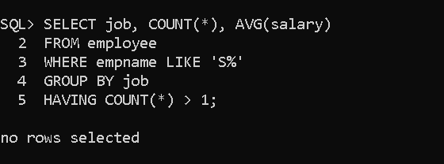

- Display the department number, number of employees, and average salary for employees born after 01-JAN-1990, considering only departments having at least 2 such employees.

SQL> select deptno, count(), avg(salary) from employee where dob >'01-JAN-1990' group by deptno having count() >=2;

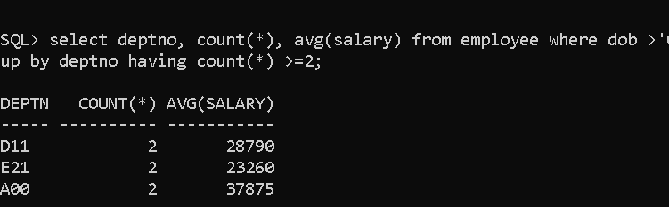

- Display the year of birth, number of employees, maximum salary, and minimum salary for employees whose names end with the letter A, considering only years having at least 2 such employees.

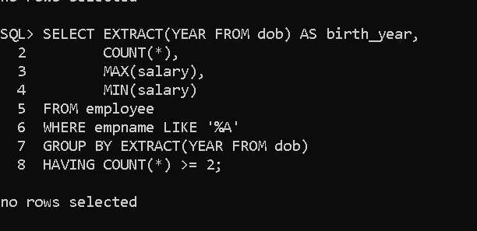

- Display the department number, total salary, average salary, and employee count for employees whose job starts with the letter A, considering only departments where the total salary exceeds 1,00,00

SQL> select deptno, sum(salary) from employee where job like 'A%' group by deptno having sum(salary)>10000;
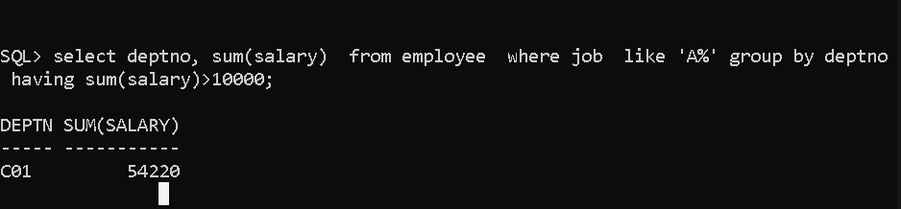

- Display the month in which employees were hired, the number of employees hired in that month, and their average salary, considering only months having at least 2 employees.

SQL> SELECT TO_CHAR(hire_date, 'MONTH') AS month, 2 COUNT() AS employee_count, 3 AVG(salary) AS average_salary 4 FROM employee 5 GROUP BY TO_CHAR(hire_date, 'MONTH') 6 HAVING COUNT() >= 2;

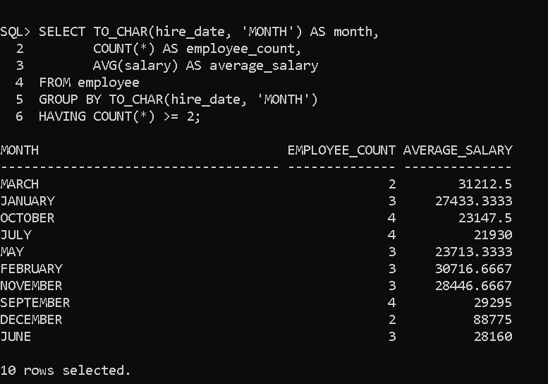

- Display the department number, gender, employee count, and average salary for employees whose names contain the substring AN, considering only department-gender groups having at least 2 employees.

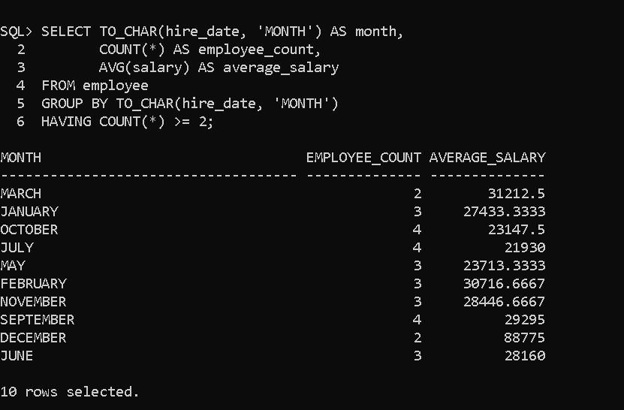

- Display the job, year of joining, number of employees, and average salary for employees hired after =, considering only job-year groups having at least 2 employees.

SQL> SELECT job, 2 EXTRACT(YEAR FROM hire_date) AS joining_year, 3 COUNT() AS employee_count, 4 AVG(salary) AS average_salary 5 FROM employee 6 WHERE hire_date > TO_DATE('01-JAN-2015','DD-MON-YYYY') 7 GROUP BY job, EXTRACT(YEAR FROM hire_date) 8 HAVING COUNT() >= 2;
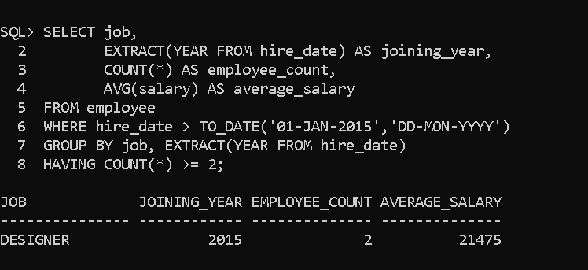

- Display the department number, number of employees, and average salary for employees whose names have more than 5 characters, considering only departments whose average salary exceeds 30,000.

SQL> select deptno, count(*), avg(salary) from employee where length(empname)>5 group by deptno having avg(salary) >30000;

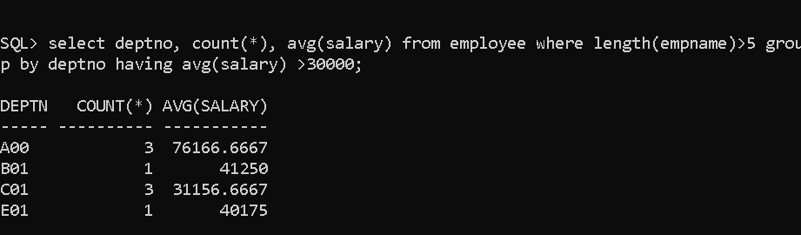

- Display the year of joining, employee count, total bonus, and average bonus for employees whose job contains the letter E, considering only years having more than 2 employees.

SQL> SELECT EXTRACT(YEAR FROM hire_date) AS joining_year, 2 COUNT() AS employee_count, 3 SUM(bonus) AS total_bonus, 4 AVG(bonus) AS average_bonus 5 FROM employee 6 WHERE job LIKE '%E%' 7 GROUP BY EXTRACT(YEAR FROM hire_date) 8 HAVING COUNT() > 2;

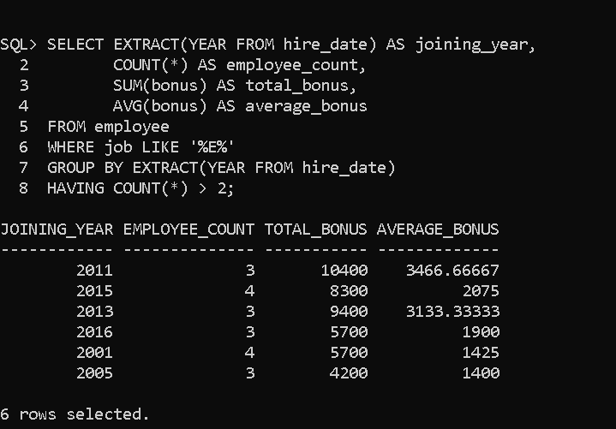

- Display the department number, number of employees, maximum salary, and minimum salary for employees whose names start with either A or M, considering only departments having at least 2 such employees.

SQL> select deptno,count(),max(salary),min(salary) from employee where empname like 'A%' or empname like 'M%' group by deptno having count() >2;
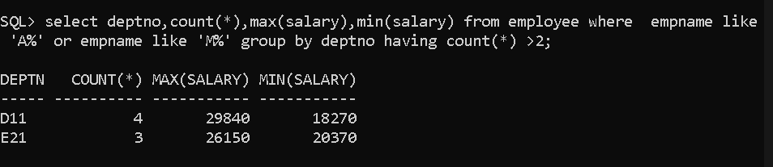

- Display the job, number of employees, average salary, and average commission for employees who joined before 01-JAN-2015, considering only jobs having more than 2 employees and an average salary greater than 25,000.

SQL> SELECT job, COUNT(), AVG(salary), AVG(comm) 2 FROM employee 3 WHERE hire_date < TO_DATE('01-JAN-2015','DD-MON-YYYY') 4 GROUP BY job 5 HAVING COUNT() > 2 6 AND AVG(salary) > 25000;

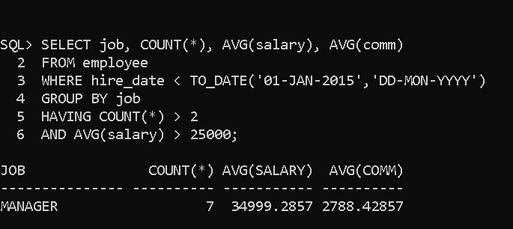

- Display the department number, year of joining, number of employees, and average salary for employees whose names contain the letter R and who joined after 01-JAN-2014, considering only department-year groups having at least 2 employees.

SQL> SELECT deptno, 2 EXTRACT(YEAR FROM hire_date) AS joining_year, 3 COUNT(), 4 AVG(salary) 5 FROM employee 6 WHERE empname LIKE '%R%' 7 AND hire_date > TO_DATE('01-JAN-2014','DD-MON-YYYY') 8 GROUP BY deptno, EXTRACT(YEAR FROM hire_date) 9 HAVING COUNT() >= 2;

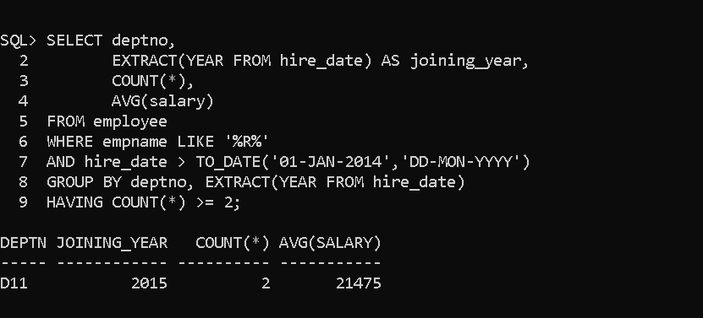

- Display the department number, employee count, average salary, and average bonus for employees whose date of birth falls in the month of January, considering only departments having at least 2 such employees and an average salary greater than 30,000.

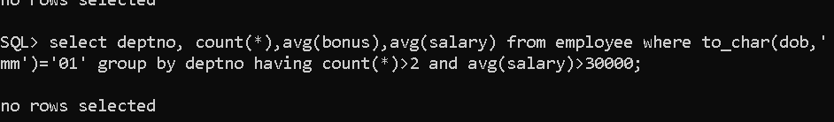

- Display the job, number of employees, total salary, and average salary for employees whose names start with a vowel, considering only jobs having at least 2 such employees and a total salary greater than 75,000.

SQL> SELECT job, COUNT(*), SUM(salary), AVG(salary)
2 FROM employee
3 WHERE empname LIKE 'A%'
4 OR empname LIKE 'E%'
5 OR empname LIKE 'I%'
6 OR empname LIKE 'O%'
7 OR empname LIKE 'U%'
8 GROUP BY job
9 HAVING COUNT(*) >= 2
10 AND SUM(salary) > 75000;

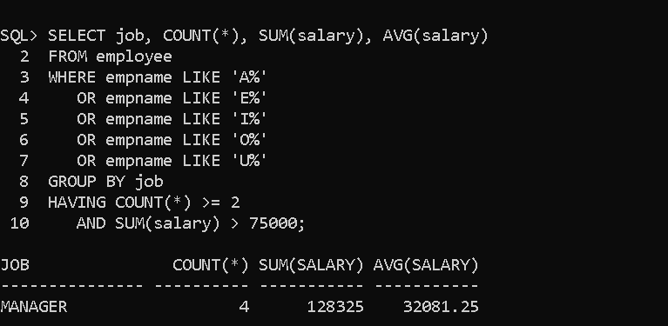

- Display the department number, number of employees, average salary, and maximum salary for employees who have completed more than 10 years of service as of 01-JAN-2025, considering only departments having at least 2 such employees.

SQL> SELECT deptno, COUNT(*), AVG(salary), MAX(salary)
2 FROM employee
3 WHERE MONTHS_BETWEEN(
4 TO_DATE('01-JAN-2025','DD-MON-YYYY'),
5 hire_date
6 ) / 12 > 10
7 GROUP BY deptno
8 HAVING COUNT(*) >= 2;
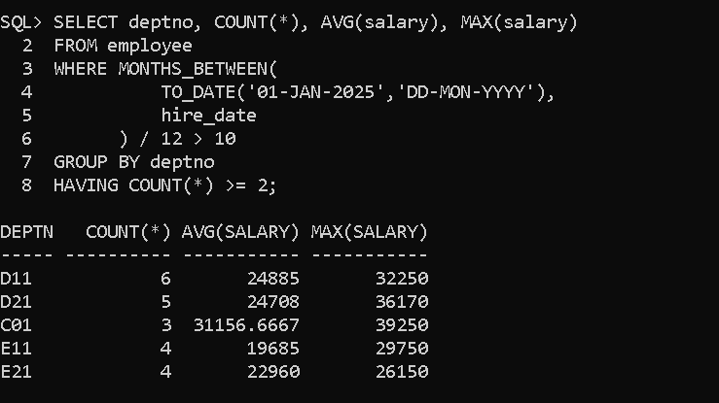

- Display the department number, job, gender, number of employees, average salary, and total bonus for employees whose names contain the letter A, who joined after 01-JAN-2010, and whose job starts with either A or M, considering only department-job-gender groups having at least 2 employees and an average salary greater than 30,000.

